NAME: M . RAKESH KUMAR COMPUTER NETWORKS

SEC:2

TASK: 3

Aim:- configuration of basic switch setup using cisco packet tracer

STEP – 1: give the connections as shown in the diagram

Components: switch , 2-pc’s, copper straight through cable

Connect the pc’s to the switch using the copper straight through cable

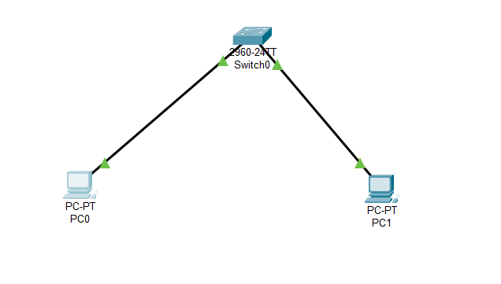

STEP – 2: click on the switch and go to CLI tab and follow the given instructions:

Router Configuration process

1. Enter privileged EXEC mode:

Switch> enable

Switch#

2. Enter global configuration mode:

Switch# configure terminal

Switch(config)a

3. Configure the switch hostname (optional):

Switch(config)# hostname s1

4. Configure VLAN 1 (default VLAN) interface with an IP address

S2(config)#

S1(config)# interface vlan 1

S1(config-if)# ip address 192.168.1.1 255.255.255.0

S1(config-if)# no shutdown

S1(config-if)# exit

S1(config)#

5. Save the configuration:

S1(config)# exit

S1# write memory

STEP – 3 Configuring the pc’s:

PC-0:

1. Click on the pc0 and go to the ip configuration tab.
2. Enter the ip address as 192.168.1.2
3. We get the subnet mask as 255.255.255.0

PC-1:

1. Click on the pc1 and go to the ip configuration tab
2. Enter the ip address as 192.168.1.3
3. We get the subnet mask as 255.255.255.0

STEP – 4 since the ip configuration is completed now we need to check the ping using the command prompt:

1. Open any 1 of the pc and go to the command prompt
2. In the command prompt enter the given command-
3. Ping 192.168.1.2

1. And again give the command
2. Ping 192.168.1.3

With this the given task is successfully executed.